**LITERATURE REVIEW**

|  |  |
| --- | --- |
| Title | Signs with smart connectivity for better road safety |
| Team Id | PNT2022TMID41963 |
| Date | 30.08.2022 |

# 1.1 INTRODUCTION

In present Systems the road signs and the speed limits are Static. But the road signs can be changed in some cases. We can consider some cases when there are some road diversions due to heavy traffic or due to accidents then we can change the road signs accordingly if they are digitalized. This project proposes a system which has digital sign boards on which the signs can be changed dynamically. If there is rainfall then the roads will be slippery and the speed limit would be decreased. There is a web app through which you can enter the data of the road diversions, accident prone areas and the information sign boards can be entered through web app. This data is retrieved and displayed on the sign boards accordingly.

**1.2 WHAT IS SIGNS WITH SMART CONNECTIVITY FOR BETTER ROAD SAFETY?**

Traffic control is a big issue in today’s world. Traffic jam is one of the major problems in a densely populated city where the population and number of running vehicles are much more than its capacity. Due to traffic jam a substantial portion of working is spent on streets which indirectly put adverse impact on economy and unavoidable road accident which results in the loss of lives. The number of vehicles is ever increasing while the city infrastructures are developing at a much slower rate. To replace the static signboards, smart connected sign boards are used. These smart connected sign boards get the speed limitations from a web app using weather API and update automatically. Based on the weather changes the speed may increase or decrease. Based on the traffic and fatal situations the diversion signs are displayed. Guide (Schools), Warning and Service(Hospitals, Restaurant) signs are also displayed accordingly. Different modes of operations can be selected with the help of buttons.

# 1.3 AUTHORS AND THEIR PROPOSAL

1. Fanny Malin⁎ , Ilkka Norros, Satu Innamaa

In the year of 2019, Accident risk of road and weather conditions on different road types. This study was designed to investigate the relative accident risk of different road weather conditions and combinations of conditions. The study applied a recently developed method which is based on the notion of Palm probability, originating in the theory of random point processes, which in this case corresponds to picking a random vehicle from the traffic.

1. Chai K. Toh1 , Juan-Carlos Cano , Carlos Fernandez-Laguia , Pietro Manzoni , Carlos T. Calafate

In the year of 2018, Wireless digital traffic signs of the future. This paper discuss about the technological advances in the areas of wireless communications and embedded electronics and software, we foresee that, in the future, digital traffic sign posts will be capable of transmitting the traffic sign information wireless to road users, and this will transform our roads into intelligent roads, where signs will appear promptly and automatically on in-vehicle displays to alert the driver.

1. Kelly Borden, Marc LaBahn, Matt Milliken, Solomon Ortega

In the year of 2017, The goal of our project was to propose current and future Intelligent Transportation Systems (ITS) solutions to decrease fatalities in areas with high crash frequency, or hotspots, in New Mexico.

1. [Redouan Lahmyed, Mohamed El Ansari](https://link.springer.com/article/10.1007/s00500-021-06726-w) & [Zakaria Kerkaou](https://link.springer.com/article/10.1007/s00500-021-06726-w)

In the year of 2022, [Redouan Lahmyed,](https://link.springer.com/article/10.1007/s00500-021-06726-w) [Mohamed El Ansari](https://link.springer.com/article/10.1007/s00500-021-06726-w) & [Zakaria Kerkaou](https://link.springer.com/article/10.1007/s00500-021-06726-w) proposed the paper “Automatic road sign detection and recognition based on neural network”. This paper describes a novel system for automatic detection and recognition of road signs, which is achieved in two main steps. First, the initial image is pre - processed using DBSCAN clustering algorithm.

## 1.4 PROPOSED SYSTEM

In present Systems the road signs and the speed limits are Static. But the road signs can be changed in some cases. We can consider some cases when there are some road diversions due to heavy traffic or due to accidents then we can change the road signs accordingly if they are digitalized. This project proposes a system which has digital sign boards on which the signs can be changed dynamically. If there is rainfall then the roads will be slippery and the speed limit would be decreased. There is a web app through which you can enter the data of the road diversions, accident prone areas and the information sign boards can be entered through web app. This data is retrieved and displayed on the sign boards accordingly.

## 1.5 Significance Of the Study

The significance of this project work are:

* It will help in reducing the occurrence of possible collision or accident and thereby improve the confidence of the driver and the pedestrian plighting through the highways.
* The Project to allay the fear of time wastage at the junctions because of unevenly directions of traffic system.
* Since the system is capable of working for 24 hours uninterrupted thereby assured constant availability of traffic control service hence reduce human effort and energy

## 1.6 Implementation

As shown in Fig. 1, the wireless digital traffic sign post architecture replaces existing physical traffic signs with posts embedded with electronics hardware and software. The hardware functions as a communication device and server. The traffic sign is then wireless transmitted to a client receiver residing in the vehicle. The client device is usually a smart phone. Traffic light control system using microprocessor and also using micro controller is a unique traffic light controller makes simple use of assembly language programming with Intel 8085 microprocessor. It permits accident free control as a separate set of signals has been assigned to a direction. For instance, if one desires to move towards north, east or west from south, he is provided a single light signals for the respective directions. Consequently, the probability of confusion leading to an accident is reduced.

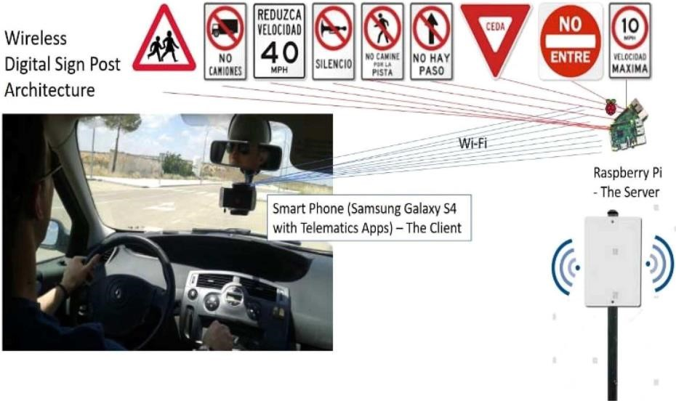

***Fig. 3:*** *Programmable wireless digital traffic sign post architecture – where the sign post is a server capable of transmitting sign wireless to the driver's client device, which can be the car HUDs, car dashboard, ADAS display device, or a smart phone.*

### INFERENCE OF LITERATURE SURVEY

The literature review of the papers that were referenced and those that serve as base paper and supporting paper helped to narrow down the main challenges that the proposed application might face. Also, it has served as a guide for the development of the application in the right way, using the necessary tools. From the Table 2.2, the following were inferred from the literature survey.

# Table: Inference of the Literature Survey

|  |  |  |  |  |  |  |  |  |  |
| --- | --- | --- | --- | --- | --- | --- | --- | --- | --- |
| **AUTHOR NAME** | | | |  | **INFERENCE** | | | | |
| Fanny Malin⁎ , Ilkka Norros, Satu Innamaa | | | |  | Accident risk of road and weather conditions on different road types | | | | |
| Chai K. Toh1 , Juan-Carlos Cano ,  Carlos Fernandez-Laguia , Pietro Manzoni  , Carlos  T. Calafate | | | |  | Wireless digital traffic signs of the future | | | | |
| Kelly Borden, Marc LaBahn, Matt Milliken, Solomon Ortega | | | |  | Improving Road Safety with  Intelligent Transportation Systems | | | | |
|  | [Redouan Lahmyed,](https://link.springer.com/article/10.1007/s00500-021-06726-w) [Mohamed El Ansari](https://link.springer.com/article/10.1007/s00500-021-06726-w) | | |  |  | Automatic road sign detection | | |  |
| [&](https://link.springer.com/article/10.1007/s00500-021-06726-w) | [Zakaria Kerkaou](https://link.springer.com/article/10.1007/s00500-021-06726-w) |  | and | | recognition based on |
|  | | neural network |  | |